**JOB PORTAL SYSTEM**

***A Project Submitted in partial fulfilment of the requirements for the award of the degree of***

**BACHELOR OF COMPUTER APPLICATION**

**BY**

**NAMAN SINGH**

**(BCA/4543/17)**



**DEPARTMENT OF COMPUTER SCIENCE AND ENGINEERING**

**BIRLA INSTITUE OF TECHNOLOGY MESRA, RANCHI**

**EXTENSION CENTER NOIDA**

**DECLARATION CERTIFICATE**

This is to certify that the work presented in the project entitled

“**JOB-PORTAL SYSTEM”**

in partial fulfilment of the requirements for the award of degree of **Bachelor of Computer Application** of Birla Institute of Technology, Extension Centre Noida is an authentic work carried out under my supervision and guidance.

To the best of my knowledge, the content of this project does not form the basis for the award of any previous Degree to anyone else.

DATE: **Dr. B.B. SAGAR**

(Assistant Professor)

Dept. of Computer Science Engineering

Birla Institute of Technology Mesra Ranchi, Noida Campus

Head

Dept. of Computer Science Engineering

Birla Institute of Technology Mesra, Ranchi

Noida Campus

**CERTIFICATE OF APPROVAL**

The foregoing project entitled **“JOB-PORTAL SYSTEM”** is hereby approved as a creditable study of research topic has been presented in satisfactory manner to warrant its acceptance as prerequisite to the degree for which it has been submitted.

It is understood that its approval, the undersigned do not necessarily endorse any conclusion drawn or option expressed therein, but approve the thesis for the purpose for which it is submitted.

**(Internal examiner) (External Examiner)**

**(Director)**

**Birla Institute of Technology Mesra**

**Ranchi**

**Noida Campus**

**ACKNOWLEDGEMENT**

Our sincere thanks to my **mentor Dr. B.B. Sagar** Sir, professor of BIT NOIDA for extending all the support and for his ideas and knowledge for all the project work. He was always ready with answers to all our doubts.

Finally, we would like to thank our friends for their valuable suggestions and inputs that proved to be of invaluable assistance and constantly motive us to learn as much as possible.

**NAMAN SINGH**

BCA/4543/17

Birla Institute of Technology , Mesra ,Ranchi

Noida Campus

**CONTENTS**

1. **INTRODUCTION**

1.1 Project Summary

1.2 Purpose

1.3 Scope

1. **SYSTEM REQUIREMENT STUDY**

2.1 User Characteristics

2.2 Hardware and Software Requirements

2.3 Constraints

1. **System Analysis**

3.1 Study of Current System

3.2 Requirement of new system

3.3 Feasibility Study

1. **Project Management**

4.1 Project Planning and Scheduling

* 1. Estimation

1. **Development Tools**

* HTML
* CSS
* JavaScript
* Bootstrap
* PHP

1. **Data Flow Diagram**

6.1 Level 0 DFD

6.2 Level 1 DFD

1. **Testing**

7.1 Testing Process

7.2 Black-Box Testing

7.3 White-Box Testing

1. **Screenshots**
2. **Reference**
3. **INTRODUCTION**
   1. Project Summary

Job portal is developed for creating an interactive job vacancy Portal for candidates.

This web application is to be conceived in its current form as a dynamic site-requiring constant updates both from the seekers as well as the companies.

The objective of the project is to enable jobseekers to place their resumes and find appropriate jobs while companies to publish their vacancies and find good candidates.

It enables jobseekers to post their resume, search for jobs, view personal job listings. It will provide various companies to place their vacancy profile on the site and also have an option to search candidate resumes.

Apart from job-seekers and Companies(Job Provider) there will be an admin module to manage complete Portal as well as jobseeker and companies.

1.2 Purpose

* We have developed the job-portal. This portal can handle data of Recruits (Several Companies) who are looking for suitable candidates for their vacancies.
* This portal will be most useful for Consultants for searching of matching job with jobseekers etc.
* The classic Functionality of this Application focuses on data storage. However, the means to retrieve and analyze data, to extract, transform and load data, and to manage the data dictionary.
* An administrator is provided through which can enter Recruiter’s record /type of jobs/jobseeker’s description. This data once entered can be edited/deleted as required when there will be vast entries of data user can scroll the data.

1.3 Scope

* There is no any online Payment gateway provided in this portal. So, any company which would register would not be able to pay online. Payment would be done by check/case.
* There are no banners for advertisement on the site.
* This system can run only on Windows platform.
* Supported only in My SQL database.
* No security of data.
* No N-level category.
* Supportive language is only English.

1. **SYSTEM REQUIREMENT STUDY**

2.1 User Characterstics

End User

* Every user should be comfortable of working with computer and net browsing.
* He must have basic knowledge of English too.
* He has must be some knowledge of how to use any websites.

Administrator

* Administrator is an entity that will manage entire system. He/she will have highest level of access rights and he will be provided with his own interface to access powerful features. An administrator can cover areas such as database, security and integration.
* He can view, modify or delete records. He can do all kind of alterations in the database.

2.2 Hardware and Software Requirements

Hardware Requirements

Processor : Pentium III 630MHz

RAM : 1GB

Hard Disk : 50GB

Monitor : 32” Colour

Board : 122 Keys

Software Requirements

Operating System : Windows 7, Windows XP, Window 8.1 Web Server

SERVER : XAMPP

Front End : HTML, CSS, JAVASCRIPT

Back End : PHP, MYSQL

2.3 Constraints

* GUI is only in English.
* To develop a system with above mentioned requirements in stimulated period of 4 months is a major time constraints. In this time frame is all software engineering activities are to be done including testing.

1. **SYSTEM ANALYSIS**

3.1 Study Of Current System

This application having database which is a repository of an organization’s electronically stored data. The databases are designed to facilitate analysis.

The classic Functionality of this Application focuses on data storage. However, the means to retrieve and analyse data, to extract, transform and load data, and to manage the data dictionary.

FUNCTIONALITY IS :

* To facilitate easy maintenance of records of various Recruiters (Companies), job and job seekers.
* To check for matching job with jobseekers.
* Quick access of all record.
* To match the suitable candidates to appropriate job.
* Prevent and reduce human error.
* Reduce manual work.

3.2 Requirement Of new System

The new system that was to be built in the organization need to have some creative concept that can help the user in the real manner and the next important thing is that it should give the cost effective solution to the user. Due to the collaborative nature of the application the user can really be an important part of it rather than just using it blindly. As the prior applications were not providing the user portability, the new application should be created for manage jobseekers and employers (recruiters) so that user can access the application at any of the corner in the world into his/her hand only. The new application also gives the user the liberty to know and use the application from the web through the web modules which gives complete information of the application.

3.3 Feasibility Study

The main purpose of feasibility analysis is to check the economic viability of the proposed system. The result of the feasibility study will indicate whether to proceed with the proposed system or not. If the results of the feasibility study are positive, then we can proceed to develop a system otherwise project should not be pursued.

### 

### Technical Feasibility

This system will be developed using Asp.net. As we require some time to learn all these technologies, All these technologies are easy to learn and can develop system very rapidly. After developing and deploying the system, any user can view this site on the Internet.

### 

### Economical Feasibility

Proposed System requires development tools and software such as visual studio 2008 which are free of cost and available on internet. For developing proposed system, we need various resources such as computers systems, internet connection for e-help, recommended disk space, and memory speed as mention in technical requirement. By looking at all these expenses and comparing with proposed system, we have many benefits from proposed system such are

* + As existing system is manual, where data may not accurate, up to date, and available on time. But proposed system will be computerized, so we can overcome all limitations of existing system. Also with this new system insertion, deletion, and modification of various data will be easier to handle.
  + This system will reduce the paperwork. And quality of data will be improved.

So keeping all above mentioned benefits and comparing with various expenditures of resources, we conclude that proposed system is economical feasible.

### Operational feasibility

Users of the system will the registered user of the website.

To put an orders user should have only basic knowledge of computer and Internet which is not a big issue.

Requirement Validation

* Username and Password validation that is compulsory to enter within system (Not for visitor).
* The user must have the email id in Gmail, yahoo or any website.
* Phone No must be Numeric and length is of maximum 11 Digit.
* Name must be character not in digit.
* Pin code No. is of 6 digits.
* For every new entry of enter all data manually, made entry by adjustment form. So it reduces mismatch in data.

1. **Project Management**

4.1 Project Planning and Scheduling

Project planning establishes a plan for the software engineering work that follows. It describes the technical tasks to be conducted, the risks that are likely, the resources that will be required, the work product to be produces, and a work schedule.

Project scheduling is an activity that distributes estimated effort across the planned project duration by allocating the effort to specific software engineering tasks. It is important to note, however, that the schedule evolves overtime. During early stages of project planning, a macroscopic schedule is developed. This type of schedule identifies all software framework activities and the product functions to which they are applied. As the project gets under way, each entry on the macroscopic schedule is refined into a detailed schedule. Here, specific software tasks ( required to accomplish an activity) are identified and scheduled.

Project Development Approach

To solve actual problems in an industry setting, software engineer or a team of engineers must incorporate a development strategy that encompasses the process, methods and tools layers and generic phase. This strategy is often referred to as process model or a software engineering paradigm. A process model for software engineering is often chosen based on the nature of the project and application, the methods and tools to be used, and the controls and deliverables that required.

To solve actual problems in an industry setting, a software engineer or a team of engineers must incorporate a development strategy that encompass the process, methods, and tool layers.

Our software is based on Linear sequential Model ( Waterfall Model)

Waterfall Model

The waterfall model derivers its name due to the cascading effect from one phase to the other as is illustrated in above figure. In this model each phase well define starting and ending point, with identifiable deliveries to the next phase.

Note that this model is sometime referred to as the linear sequential model or the software life cycle model.

Starting from the existing situation, we proceed towards the desired solution in a number of steps.  At each of these steps the Waterfall Model is followed. Consider a *Linear sequential Model* lifecycle model which consists of repeating the following five phases in sequence:

* The water fall diagram is basically divided into following 5 models.
* Requirement
* Design
* Implementation
* Verification
* Maintenance

**Software Engineering Paradigm Applied**

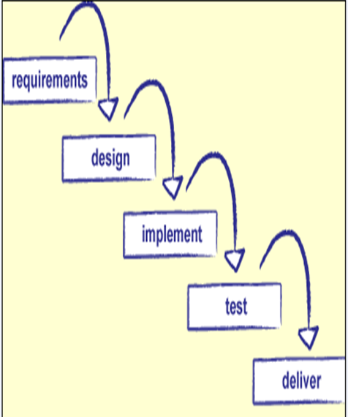

**Requirement:-**

In the requirement phase the need to create the application is specified. What is the need of the system is defined. What information to be feeder to create the application will come under the requirement phase?

**Design:**

After the requirement phase the next phase is the Design phase where the application is designed according to the forms and other modules created. This phase is much important phase because it will structure the layout of your application.

**Implementation:**

Implementation is the process of having a system personnel phase check out and put new equipment into use, train users, install new application and construct any file of data need to use it.

**Verification:**

After the whole application is being the developed the main phase is the verification phase where the whole application tested and verified to check the whole application.

**Maintenance:**

After the successful verification of the application the main phase is the maintenance phase where the application needs to be maintained for its successful operation in future.

4.2 Estimation

Software project management begins with a set of activities that are collectively called project planning. Before the project can begin, the project manager and the software team must estimate the work to be done, the resource that are required, and the time that will elapse from start to finish. Only when this completes, development can proceed further.

There are two commonly used estimation techniques are:

* LOC - based estimation
* FP – based estimation

While estimating, project planner begins with a bounded statement of software scope and from this statement attempts to decompose software into problem functions that can each be estimated individually. LOC or FP ( the estimation variable) is then estimated for each function.

1. **Development Tools**

* **HTML**
* HTML stands for HYPER TEXT MARKUP LANGUAGE.
* Before going to know about HTML, you should know the importance of HTML.
* HTML is used for web designing, ever you think how web browser display web pages for you.
* HTML is a set of markup tags which contains the information that tells the web browser(Web browser read HTML tags and interpret into human readable content) what should be displayed.
* Using HTML, you create user interface for web applications and mobile applications. HTML was published as a W3C recommendation.
* **CSS**

CSS is the language for describing the presentation of Web pages, including colours, layout, and fonts. It allows one to adapt the presentation to different types of devices, such as large screens, small screens, or printers. CSS is independent of HTML and can be used with any XML-based mark-up language. The separation of HTML from CSS makes it easier to maintain sites, share style sheets across pages, and tailor pages to different environments. This is referred to as the separation of structure (or: content) from presentation.

* **JAVASCRIPT**

There are many programming languages out there. Why should you use JavaScript?

[JavaScript](https://developer.mozilla.org/en-US/docs/Glossary/JavaScript) is a scripting language that enables you to create dynamically updating content, control multimedia, animate images, and pretty much everything else. (Okay, not everything, but it is amazing what you can achieve with a few lines of JavaScriptcode.

* **BOOTSTRAP**

Bootstrap is a framework to help you design websites faster and easier. It includes HTML and CSS based design templates for typography, forms, buttons, tables, navigation, modals, image carousels, etc. It also gives you support for JavaScript plugins.

* **PHP**

HP stands for Hypertext Preprocessor and is a server-side programming language.

There are many reasons to use PHP for server side programming, firstly it is a free language with no licensing fees so the cost of using it is minimal.

A good benefit of using PHP is that it can interact with many different database languages including MySQL. We work with MySQL at Bluelinemedia since this is also a free language so it makes sense to use PHP. Both PHP and MySQL are compatible with an Apache server which is also free to license. PHP can also run on Windows, Linux and Unix servers.

Due to all these languages being free it is cheap and easy to setup and create a website using PHP.

PHP also has very good online documentation with a good [framework](http://www.bluelinemedia.co.uk/blog/shouldyouuseframeworkswhencoding) of functions in place. This makes the language relatively easy to learn and very well supported online. There are countless forums and tutorials on various PHP methods and problems so it is usually very easy to find help if you need it.

* **XAMPP**

XAMPP  is a [free and open-source](https://en.wikipedia.org/wiki/Free_and_open-source) [cross-platform](https://en.wikipedia.org/wiki/Cross-platform) [web server](https://en.wikipedia.org/wiki/Web_server) [solution stack](https://en.wikipedia.org/wiki/Solution_stack) package developed by Apache Friends, consisting mainly of the [Apache HTTP Server](https://en.wikipedia.org/wiki/Apache_HTTP_Server), [MariaDB](https://en.wikipedia.org/wiki/MariaDB" \o "MariaDB) [database](https://en.wikipedia.org/wiki/Database), and [interpreters](https://en.wikipedia.org/wiki/Interpreter_(computing)) for scripts written in the [PHP](https://en.wikipedia.org/wiki/PHP) and [Perl](https://en.wikipedia.org/wiki/Perl) [programming languages](https://en.wikipedia.org/wiki/Programming_language). Since most actual web server deployments use the same components as XAMPP, it makes transitioning from a local test server to a live server possible.

XAMPP's ease of deployment means a [WAMP](https://en.wikipedia.org/wiki/WAMP) or [LAMP](https://en.wikipedia.org/wiki/LAMP_(software_bundle)) stack can be installed quickly and simply on an operating system by a developer, with the advantage that common add-in applications such as [WordPress](https://en.wikipedia.org/wiki/WordPress) and [Joomla!](https://en.wikipedia.org/wiki/Joomla!) can also be installed with similar ease using [Bitnami](https://en.wikipedia.org/wiki/Bitnami" \o "Bitnami).

1. **Data Flow Diagram**

6.1 Level 0 DFD

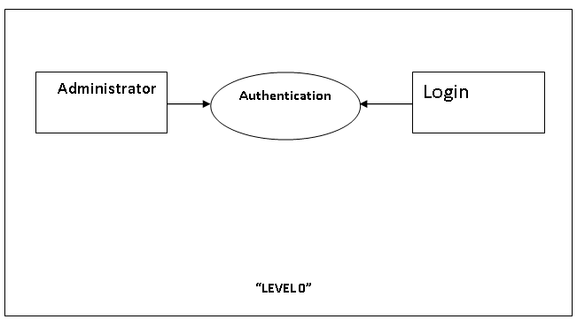

Administrator DFD

6.2 Level 1 DFD

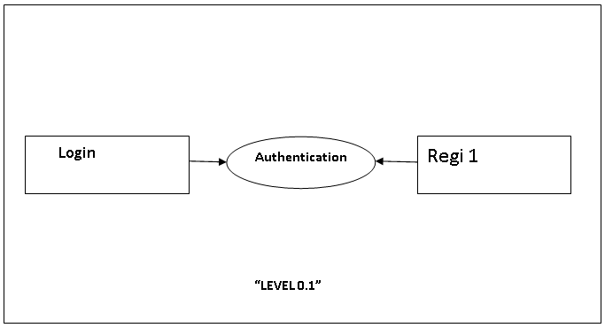

1. **Testing**

7.1 Testing Process

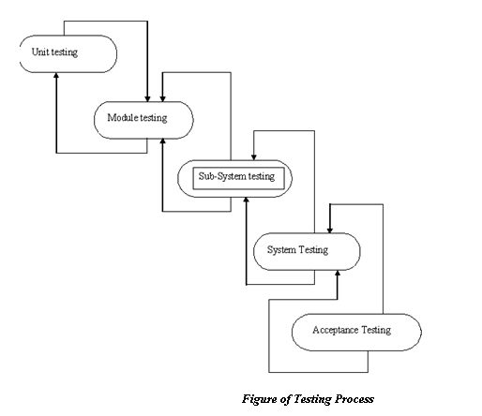

Developer tests the software process activity such as design, implementation and the requirement engineering. Because, design errors are very costly to repair when the system has been started to operate. Therefore, it is quite obvious to repair them at early stage of the system. So, analysis is the most important process of any project.

REQUIREMENTS TRACTABILITY

As most interested portion is whether the system is meeting its requirements or not, for that testing should be planned so that all requirements are individually tested. Developer checked the output of certain combinations of input, which gives desirable results, or not. Strictly stick to our requirements specifications, give you the path to get desirable results from the system.

TESTED ITEMS

Our tested items are like:

* Data fetching from the database
* Data insertion, updating and deleting in the database
* Form access to particular login

TESTING SCHEDULE

Developer has tested each procedure back to back so that errors and omissions can be found as earliest as possible. Once the system has been developed by fully developer tested it on other machines, which differs in configuration.

TESTING METHODS

Software testing involves executing an implementation of the software which tests data and examining the outputs of the software and its operational behaviour to check that it is performing as required.

STATISTICAL TESTING

Statistical testing is used to test the program’s performance and reliability and to check how it works under operational conditions. Tests are designed to reflect the actual user inputs and their frequency.

The stages involved in the static analysis for this system are follows:

* Control Flow Analysis
  + Unreachable code
  + Unconditional branches into loops
* Data Use analysis
* Variable used before initialization
* Variables declared but never used
* Variables assigned twice but never used between assignments
* Possible array bound violations
* Declared variables
* Interface Analysis
* Parameter type mismatches
* Parameter number mismatches
* Non-usage of the results of function
* Uncalled functions and procedures
* Storage Management Faults
  + Data not stored in proper tables
  + Data cannot be fetched from proper table

DEFECT TESTING

Defect testing is intended to find inconsistencies between a program and its specifications. These inconsistencies are usually due to the program faults or defects.

UNIT TESTING:-

The Developer carries out unit testing in order to check if the particular module or unit of code is working fine. The unit testing comes at the very basic level as it is carried out as and when the unit of the code is developed or a particular functionality is built.

In this application we test one most important module as task allocation which is as follows:

LOOP TESTING:

Tester has tested the some condition in a code of application. So they test the looping in source code of application for finding miss route or any error or wrong direction of flow in code.

7.2 Black-Box Testing

In black box testing or functional testing, the developer is concerned about the output of the module and software, i.e. whether the software gives proper output as per the requirements or not. In another words, these testing aims to test a program behavior against specification without making any reference to the internal structure of the program or the algorithms used. Therefore, the source code is not needed, and so even purchased modules can be tested. The program just gets a certain input and its functionality is examined by observing the output.

This can be done in the following way:

* Input Interface
* Processing
* Output Interface

The tested program gets certain inputs. Then the program does its job and generates a certain output, which is collected by a second interface. This result is then compared to the excepted output, which has been determined before the test.

7.3 White-Box Testing

It is also called ***‘GLASS BOX’*** or ***‘STRUCTURAL’*** testing. Tester has access to the system design.

* Simple Loops
* Nested Loops
* Concatenated Loops
* Unstructured Loops
* Continuous Loops

***They can:***

* Examine the design document
* View source code
* Individual path examine
* Logical path examine one time
* Logical decision on their true and false

The intention in white-box testing is to ensure that all possible feasible flow of control path through a sub-program is traversed while the software is under tested. This is not the same as saying that all statements in the sub-program will be executed as it is possible for all statements to be executed but for not all of the possible paths to be traversed. However, the conversed is true; whether all the possible paths through a sub-program are traversed then all statements in sub-programs will necessarily be executed.

When considering the number of possible paths through a sub-program two other factors need to be remembered. The first is that some of the possible paths through a sub-program turnout upon investigation to be non- feasible paths. The second consideration is that the number of possible paths to a sub-program indicated by a flow-graph analysis will indicate the minimum number of paths to ensure complete coverage. This may be less than the total number of paths which are possible when combinations of paths are allowed.

White-box testing is used as an important primary testing approach. Here, code is inspected to see what it does. Tests are designed to exercise the code. Code is tested using code scripts driver etc. which are employee to directly interfaced with and drive the code.

The tester can analyse the code and used the knowledge about the structure of a component to derive the test data.

1. **Screenshots**

**Login Page**

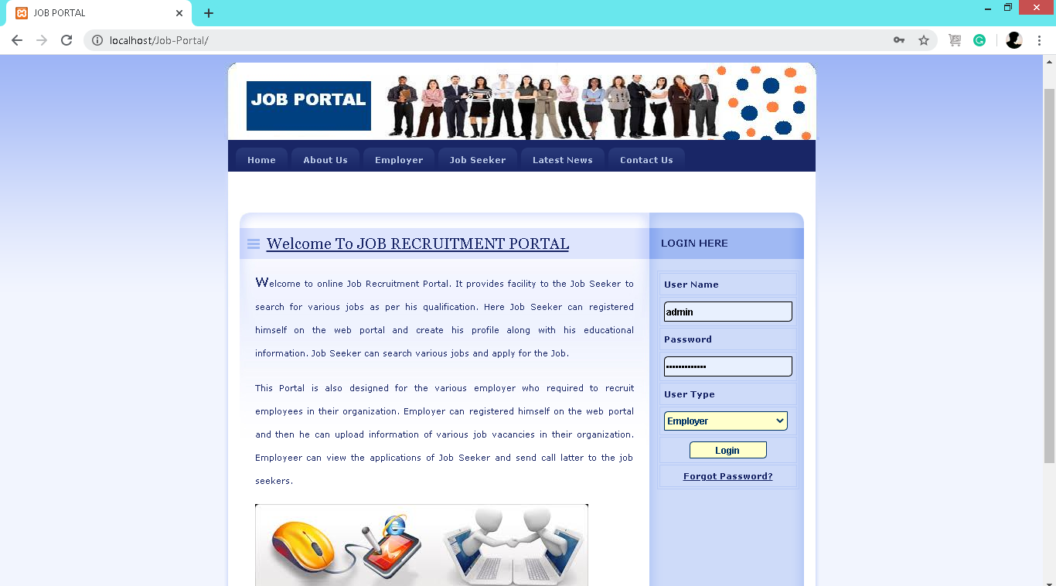

**Admin Home Page:**

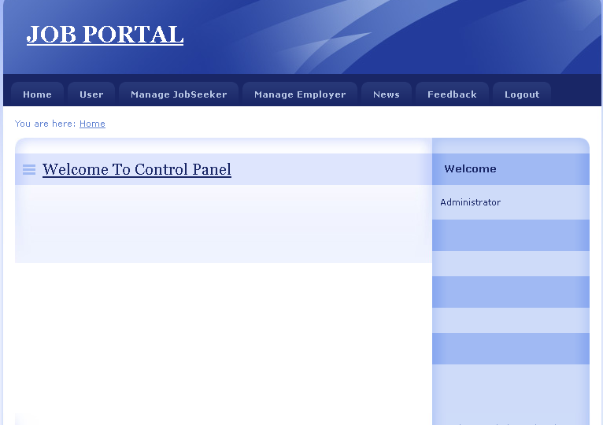

**User Control Panel:**

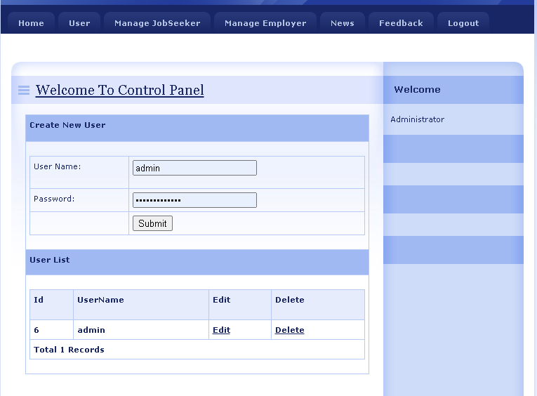

**News Page:**

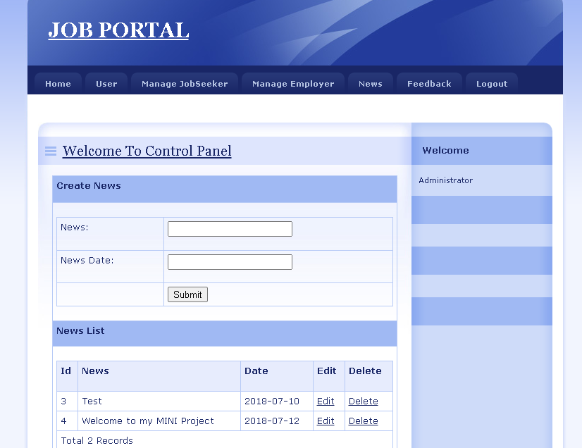

**Employee’s Home Page:**

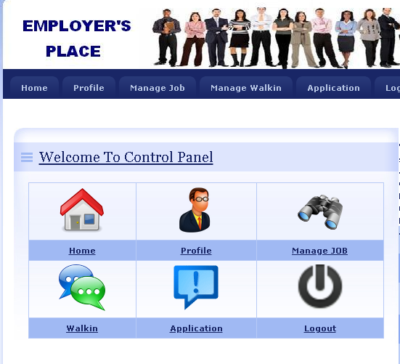

**Job Seeker’s Home Page:**

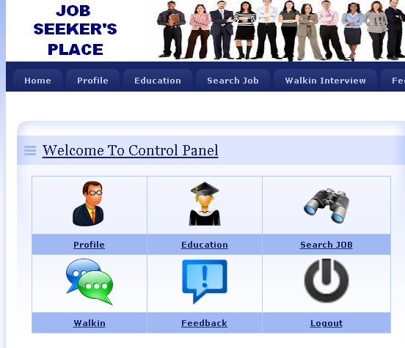

1. **Reference**

* Udemy.com/Courses
* Monster.com
* System Analysis and Design BOOK